Which equation defines the lattice energy of the ionic compound, $XY$?
A. $X_{\left(s\right)}+Y_{\left(s\right)}→XY_{\left(s\right)}$
B. $X_{\left(g\right)}+Y_{\left(g\right)}→XY_{\left(s\right)}$
C. $X_{\left(g\right)}^{+}+Y_{\left(s\right)}^{-}→XY_{\left(s\right)}$
D. $X_{\left(g\right)}^{+}+Y_{\left(g\right)}^{-}→XY_{\left(s\right)}$
ANSWER: D
The lattice energies of the compounds caesium chloride, caesium fluoride, sodium chloride and sodium fluoride are given below. Which value corresponds to the lattice energy of caesium chloride?
A. -661 kJ/mol
B. -747 kJ/mol
C. -780 kJ/mol
D. -918 kJ/mol
ANSWER: A
In NaCl, each $Na^{+}$ ion is surrounded
A. 6 $Cl^{-}$ ions
B. 4 $Cl^{-}$ ions
C. 12 $Cl^{-}$ ions
D. 8 $Cl^{-}$ ions
ANSWER: A
Lattice points have another name which is called lattice
A. sites
B. arrangements
C. circles
D. array
ANSWER: A
In the crystal lattice ions are arranged in
A. Two dimension
B. Three dimension
C. Four dimension
D. Single dimension
ANSWER:
The points which show the position of atoms in a crystal are called lattice.
A. points
B. lines
C. circles
D. arrangements
ANSWER: A
The crystal lattice is actually
A. Array of points
B. lines of points
C. sum of points
D. triangle of points
ANSWER:
The crystal lattice is also known as
A. Lattice triangle
B. Space lattice
C. Lattice line
D. Lattice array
ANSWER: B
How many $Cl^{-}$ ions are present at each corner of the cube? Answer with the help of diagram.
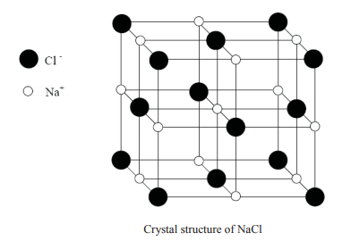
A. 4
B. 6
C. 8
D. 10
ANSWER: C
What is the coordination number of $Na^{+}$ ion in NaCl crystal?

A. 6
B. 8
C. 10
D. 18
ANSWER: A
The crystalline structure of NaCl is
A. Hexagonal close packing
B. Face-centered cubic
C. Square planar
D. Body-centered cubic
ANSWER: B

Select the correct statement(s) for the rock -salt structure (NaCl).
A. The tetrahedral sites are smaller than the octahedral sites.
B. The octahedral sites are occupied by cations and the tetrahedral sites are empty.
C. The radius ratio is $\frac{r_{+}}{r_{-}}$ is 0.225
D. Both A and B
ANSWER: D
The tetrahedral voids formed by CCP arrangement of $Cl^{-}$ ions in rock salt structure are:
A. occupied by $Na^{+}$ ions
B. occupied by $Cl^{-}$ ions
C. occupied by either $Na^{+}$ or $Cl^{-}$ ions
D. vacant
ANSWER: D
The positions $Cl^{-}$ ions in NaCl structure are:
A. corners of the cube
B. centres of faces of the cube
C. corners as well as centres of the faces of the cube
D. edges of the cube
ANSWER: C

